HWA CHONG INSTITUTION
2010 H2 CHEM PRELIMINARY EXAMINATION
9647 PAPER 3 ANSWERS

1 | (a) | (i) | P₄(s) + 5O₂(g) → P₄O₁₀(s)  OR 4P(s) + 5O₂(g) → P₄O₁₀(s)  OR 2P(s) + O₂(g) → P₂O₅(s)  P₄O₁₀(s) + 6H₂O(l) → 4H₃PO₄(aq)  OR P₂O₅(s) + 3H₂O(l) → 2H₃PO₄(aq)
 |  | (ii) | pH = 2
 | (b) | (i) | It is the enthalpy change when 1 mol of POCl₃(l) is formed from its constituent elements in their standard states ( i.e., P₄(s), O₂(g) and Cl₂(g) ) under standard conditions of 25 ºC and 1 atm.
 |  | (ii) | ΔH_{r}  –444 –286  = –730 kJ mol^{–1}  PCl₅(s) + H₂O(l) POCl₃(l) + 2HCl(g)  –1186 –92×2  = –1370 kJ mol^{–1}  P(s) + 5/2 Cl₂(g) + H₂(g) + ½ O₂(g)
By Hess’ law,
ΔH_{r} = +730 + (–1370) = –640 kJ mol^{–1}
 | (c) | (i) | Q: | R: | T:
 |  |  | 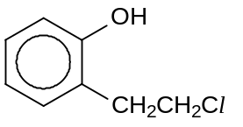 | 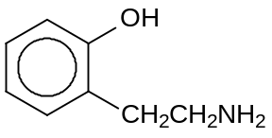 | 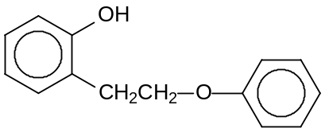
 |  | (ii) | K₂Cr₂O₇(aq), H₂SO₄(aq), heat under reflux
 |  | (iii) | LiAlH₄ in dry ether
 |  | (iv) | White fumes of corrosive (OR irritating) fumes of HCl formed.  The reaction should be carried out in a fume cupboard (OR fumehood).
 | (d) | (i) | K_{a} = 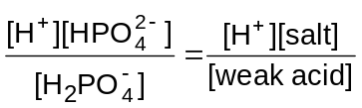  ⇒ [H⁺] = 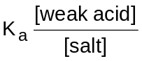 = 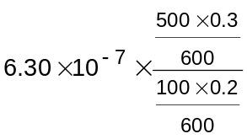 = 4.725 × 10^{–6} mol dm^{–3}  ∴ pH = –lg [H⁺] = 5.33
 |  | (ii) | When a small amount of H⁺(aq) ions are added,  HPO₄^{2–} + H⁺ → H₂PO₄–  When a small amount of OH–(aq) ions are added,  H₂PO₄– + OH– → HPO₄^{2–} + H₂O
 | (e) | (i) | 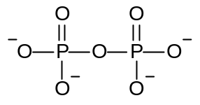
 |  | (ii) | Tetrahedral about P  Bent (or V-shaped) about –O–

2 | (a) | (i) | A system is said to be in dynamic equilibrium when the rate of forward reaction is equal to the rate of backward reaction.  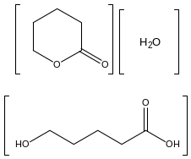
 |  | (ii) | K_{c} =
 |  | (iii) | K_{c} = 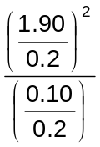= 180.5 mol dm⁻³
 |  | (iv) | The rate increases at first when the carboxylic acid is first formed because it partially dissociates to give H⁺ which catalyses the hydrolysis of ester.  The rate decreases as the reaction proceeds due to decrease in the concentration of the ester, leading to decrease in frequency of effective collisions.
 | (b) | (i) | The enzyme lowers the activation energy or providing an active site for reacting particles to come close together.
 |  | (ii) | 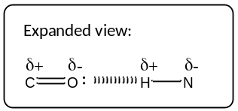  H  N  C  O  H  N  C  O  hydrogen bonds  R  R  R  R
2 | (b) | (iii) | 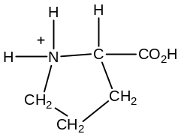
 |  | (iv) | F: disulphide bridge -CH₂-S-S-CH₂-  G: hydrogen bonding (include diagram between –CH₂OH and any other suitable group)
 | (c) | (i) | Homogeneous catalyst
 |  | (ii) | a few drops of cobalt (II) is used and can be recovered unchanged at the end of the reaction  solution turned from pink → green → pink: cobalt (II) is regenerated in the reaction  the formation of the green intermediate  rapid effervescence → CO₂ is formed quickly in the presence of cobalt (II): rate increases
 |  | (iii) | C₄H₆O₆ + 5H₂O₂ → 4CO₂ + 8H₂O

3 | (a) | Magnesium chloride has a giant ionic lattice structure.  It dissolves in water to form a slightly acidic solution as Mg²⁺ has a high charge density and undergoes hydrolysis in water.  MgCl₂(s) + 6H₂O(l) à [Mg(H₂O)₆]²⁺(aq) + 2Cl¯(aq)  [Mg(H₂O)₆]²⁺(aq) + H₂O(l) [Mg(H₂O)₅(OH)]⁺(aq) + H₃O⁺(aq)  Silicon chloride is a simple covalent molecule with dispersion forces between molecules. It undergoes complete hydrolysis in water to give a highly acidic solution of pH 1-2.  SiCl₄(l) + 2H₂O(l) à SiO₂(s) + 4HCl(aq)  OR SiCl₄(l) + 4H₂O(l) à SiO₂.2H₂O(s) + 4HCl(aq)
 | (b) | HCl: no visible reaction  HI: violet fumes of I₂ observed.  H-X bond energy / kJ mol⁻¹ : H-Cl (431); H-I (299).  The bond strength of H-Cl is greater than H-I.  OR Thermal stability of HCl is greater than HI.
 | (c) | (i) | Anode: 2Cl¯(aq) à Cl₂(g) + 2e  Cathode: 2H₂O(l) + 2e à H₂(g) + 2OH¯(aq)
 |  | (ii) | Q = I x t = 5 x 7 x 60 x 60 = 1.26 x 10⁵ C  Q = n_{e} x F  No. of moles of electrons passed = 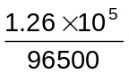 = 1.306 mol  No. of moles of chlorine = 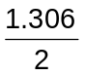= 0.6529 mol  Mass of chlorine produced = 0.6529 x 2 x 35.5 = 46.4 g
 |  | (iii) | Cl₂ + 2e⁻ 2Cl⁻ E○ = +1.36V -----(1)  O₂ + 4H⁺ +4e⁻ 2H₂O E○ = +1.23V  When dilute sodium chloride is used, the E○(O₂/H₂O) is less positive than E○(Cl₂/Cl─) and H₂O is preferentially oxidised at the anode to give O₂ gas.
 | (d) | (i) | Disproportionation  Cl₂(aq) + 2NaOH(aq) à NaCl (aq) + NaClO(aq) + H₂O(l)  OR Cl₂(g) + 2NaOH(aq) à NaCl (aq) + NaClO(aq) + H₂O(l)
 |  | (ii) | 3Cl₂(aq) + 6NaOH(aq) à 5NaCl(aq) + NaClO₃(aq) + 3H₂O(l)  OR 3Cl₂(g) + 6NaOH(aq) à 5NaCl(aq) + NaClO₃(aq) + 3H₂O(l)
 | (e) | (i) | Nucleophilic addition
 |  | (ii) | I : ethanolic KCN, heat  II : dilute H₂SO₄, heat OR dilute HCl, heat  III : PBr₃, heat OR red phosphorus with Br₂, heat  H : 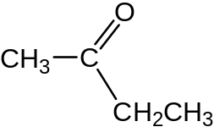

4 | (a) | (i) | +3
 |  | (ii) | Orange / red / yellow
 |  | (iii) | In the presence of an octahedral ligand field, the degenerate d-orbitals will split into two energy levels.  In the partially filled d-orbitals (d⁴) , electrons are able to promote from the lower to the higher level by absorbing energy in the visible spectrum (blue-green).  The colour shown is the complementary colour (orange-red or yellow).
 | (b) | (i) | SO₄²⁻  [R] MnO₄⁻ + 8H⁺ + 5e → Mn²⁺ + 4H₂O E○ +1.52 V  [O] SO₄²⁻ + 2H⁺ + 2e → SO₃²⁻ + H₂O E○ < +1.52 V
 |  | (ii) | From the titration results,  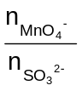 = 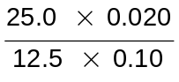 = 0.4 or 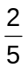  Each mol of MnO₄⁻ accepts 5 mol of electrons when reduced to Mn²⁺.  This means 2 mol of MnO₄⁻ accepts 10 mol of e⁻ from 5 mol of SO₃²⁻;  or each SO₃²⁻ ion loses 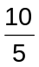 = 2 electrons.  Hence oxidation state of S increases by 2 units from +4 (in SO₃²⁻) to + 6 (in SO₄²⁻)
 | (c) | (i) | When [Fe²⁺] = [Fe³⁺] , ln 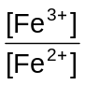 = 0.  Hence, E = E○ (Fe³⁺/Fe²⁺) = +0.77 V.
 |  | (ii) | Vol of KMnO₄ = 50.0 cm³
 |  | (iii) | The equivalence point is reached between 80 and 120 cm³ (precisely at 100 cm³). This means that the E value switches from a calculation based on Fe³⁺/Fe²⁺ to one based on MnO₄⁻/Mn²⁺.
 |  | (iv) | The E value of MnO₄⁻/Mn²⁺ (and hence, the oxidizing power of MnO₄⁻) is dependent on [H⁺];  or changes in [H⁺] affects the value of the measured E, because of  MnO₄⁻ + 8H⁺ + 5e  Mn²⁺ + 4H₂O.
 | (d) | J K L  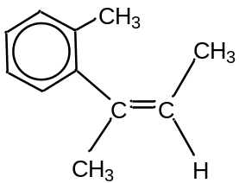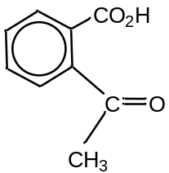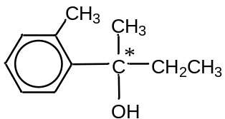

5 | (a) | (i) | Mg²⁺ cation has a higher charge density and distorts the carbonate electron cloud more. Hence, MgCO₃ decomposes at a lower temperature than BaCO₃.  MgCO₃(s) → MgO(s) + CO₂(g)  OR  Ba_{x}Mg_{y}(CO₃)_{z} → xBaCO₃ + yMgO + yCO₂
 |  | (ii) | Ba_{x}Mg_{y}(CO₃)_{z}(s) → xBaO(s) + yMgO(s) + zCO₂(g)  n_{CO2} = 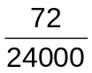= 0.003 mol  BaO(s) + 2HNO₃(aq) → Ba(NO₃)₂(aq) + H₂O(l)  Similarly, Mg(NO₃)₂ is also formed.  Ba(NO₃)₂(aq) + H₂SO₄(aq) → BaSO₄(s) + 2HNO₃(aq)  nBaSO₄ = nBaO = 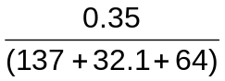= 0.001502 mol  x : z  =1 : 2  By balancing O atoms,  3z = x + y + 2z  ⇒ z = x + y  ⇒ x = y  ∴ x = y = 1; z = 2
 |  | (iii) | CO forms strong dative bond with Fe²⁺ of haemoglobin OR undergo ligand exchange and this is an irreversible process.  Thus haemoglobin is unable to transport oxygen , causing death as the body is deprived of oxygen.
 | (b) | (i) | Fe shows variable oxidation states due to the close similarity in energy of the 4s and 3d electrons. Hence, once the 4s electrons are removed, some or all the 3d electrons may also be removed without requiring much more energy.  For Ca, once the outermost electrons in the s orbitals are removed, subsequent removal of electrons would be from the inner quantum shell which requires too much energy.
 |  | (ii) | In Ca, only 2 valence electrons are involved in metallic bonding. In Fe, both 3d and 4s electrons are involved in metallic bonding due to their proximity in energy. More energy required to overcome the stronger metallic bonding in Fe than in Ca.
 | (c) | (i) | Mg(OH)₂(s) 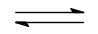 Mg²⁺(aq) + 2OH⁻(aq)  pH = 10.5, pOH = 14 – 10.5 = 3.5  [OH⁻] = 10^{-3.5} = 3.162 x 10⁻⁴ mol dm⁻³  [Mg²⁺] = 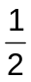 x 3.162 x 10⁻⁴ = 1.581 x 10⁻⁴ mol dm⁻³  M_{r} of Mg(OH)₂ = 58.3  Solubility of Mg(OH)₂ = [Mg(OH)₂(aq)]  = [Mg²⁺]  =1.581 x 10⁻⁴ x 58.3 = 9.217 x 10⁻³ g dm⁻³  = 9.22 x 10⁻³ g dm⁻³
 |  | (ii) | K_{sp} of Mg(OH)₂ = [Mg²⁺] [OH⁻]²  = (1.581 × 10⁻⁴) (3.162 × 10⁻⁴)²  = 1.581 x 10⁻¹¹ mol³ dm⁻⁹  = 1.58 x 10⁻¹¹ mol³ dm⁻⁹
 | (d) | (i) | A and B but not C react with Tollens’ reagent ⇒ A and B are aldehydes, C is a ketone.  A and C react with alkaline aqueous iodine to give a yellow ppt ⇒ have  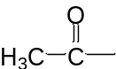 group.  ∴ A: CH₃CHO; B: HCHO; C: (CH₃)₂CO
 |  | (ii) | CH₃CO₂ˉ + CH₃CH₂Br → CH₃CO₂CH₂CH₃ + Brˉ  sweet-smelling liquid  D: CH₃CO₂ˉ  Nucleophilic substitution
 |  | (iii) | HCHO will be oxidised to HCO₂H which is unstable and thus decomposes to form CO₂ gas and H₂O.

